**Figure 1: How Cryptocurrency works**

**Data Summary**

Time series analysis is concerned with the analysis of data collected over time. Adjacent observations are typically dependent. Time series analysis hence deals with techniques for the analysis of this dependence.

**We create a zoo objects called btc from the daily closing prices of Bitcoin and ltc from the daily closing prices of Litecoin which are stored in the CSV files.** Each line on the sheet contains a date and a closing price separated by a comma. The first line contains the column headings (Date and Close). To get a first impression of the data, we plot the price chart:

**Figure 2: Closing prices of Bitcoin and Litecoin**

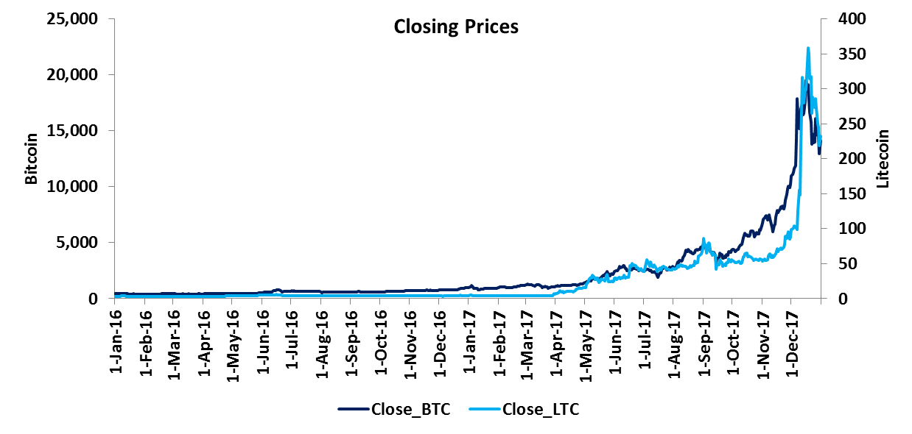

**Table 1: Date Range and Data Range**



When dealing with time series, one is normally more interested in returns instead of prices. This is because returns are usually stationary. So we will calculate continuously compounded returns:

**ret_btc = diff(log(btc)) * 100**

**Cross hedging Bitcoin**

Since the price of Bitcoin can be very volatile, most investors should hedge at least part of their exposure to Bitcoin price changes. In the absence of Bitcoin OTC instruments, investors can use related cryptocurrencies for hedging purposes. In this example Litecoin has been used to hedge.

**Cointegration: The idea behind cointegration is to find a linear combination between non-stationary time series that result in a stationary time series. It is hence possible to detect stable long-run relationships between non-stationary time series.**

Testing Bitcoin for stationarity: The null hypothesis of non-stationarity (Bitcoin time series contains a unit root) cannot be rejected at the 1% significance level

**Table 2: Testing Bitcoin for stationarity**



Testing Litecoin for stationarity: The null hypothesis of non-stationarity (Litecoin time series contains a unit root) cannot be rejected at the 1% significance level

**Table 3: Testing Litecoin for stationarity**

adf_ltc <- ur.df(btc, type = "drift")

summary(adf_ltc)

Now we try to estimate the hedge ratio by using an existing long-run relationship between the levels of Bitcoin and Litecoin prices. We obtain a hedge ratio of 61.23.

**Table 4: Estimating hedge ratio**



Testing error for stationarity: The null hypothesis of non-stationarity (error time series contains a unit root) is rejected at the 1% significance level

**Table 5: Testing error for stationarity**

